**CSSE3101 – ADVANCED WEB TECHNOLOGIES**

**Exercise 6 – React Basics (Components, Routers, Hooks and Lists)**

**Create a React application that computes the total marks of the students.**

**Part 1 – Creating Components**

1. Create a new react app: **studentmarks**
2. Create a folder **Components** and create the following components inside the created folder. Refer to the screenshots for the content for each component.
   1. **Home**

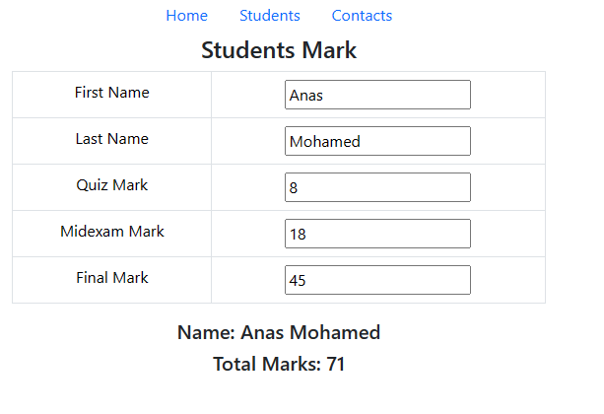

* 1. **StudentsList**

**Part 2 – Creating Routes**

1. Update your App.js and use the React Router to create routes to the two components.
   1. /- render the **Home** component
   2. /stdlist- render the **StudentsList** component
   3. /contacts - render the **Contacts** component

**Part 3 – Creating Hooks**

1. In the **Home** component:
   1. Create the appropriate code needed to implement the functionality as shown in the video.

**Part 4 – Using list and map() function**

1. In the **StudentsList** component:
   1. Create a list of students with at least 5 default values.
   2. Display these students in select when the page renders.

**Part 5 – Creating Contacts component**

1. Create a Contact component to show your contact details..